KINETIC MAIL
A Client-Side, Automated Zero-Trust Unified Email Intelligence Platform

1. INTRODUCTION

1.1 The Digital Dashboard Paradox
Email is the single most critical dashboard for modern professional, personal, and financial life. The average user balances three to four separate accounts across different providers just to keep their life organized. Yet, the foundation of email remains fundamentally broken, highly fragmented, and completely insecure.
Current dominant market solutions like Gmail and Outlook force users into a dangerous compromise: sacrificing absolute privacy for basic convenience. By shifting all email data processing to remote cloud servers, these tech giants have turned the inbox into an open door for corporate profiling, invasive tracking, and post-delivery phishing exploits.

1.2 Core Mission
Kinetic Mail fixes this by introducing absolute data sovereignty driven by complete automation. It brings multiple mailboxes (Gmail, Outlook, Yahoo, and legacy IMAP like Rediffmail) into a single, clean on-device application.
By executing all security screening, automated financial ledger formatting, and conversational AI search indexing natively on the client device, it ensures that your private data remains hands-free, automated, and entirely on your physical phone or computer.

2. THE PROBLEM (WHAT LUBRICATES INBOX WARFARE?)
Kinetic Mail directly tackles four severe, industry-wide problems that standard email applications actively ignore or fail to prevent:

Problem A: The Illusion of Privacy & Cloud AI Exposure
Traditional email clients hold the master decryption keys to your personal emails on their remote cloud servers. They read and process your text data remotely to train their AI models and build advertising profiles. If a hacker intercepts a cloud session token, your entire corporate, personal, and financial history is exposed in plaintext.

Problem B: Hidden Tracking Pixels (Corporate Espionage)
Marketers and corporate senders routinely weaponize invisible $1×1$ image tags embedded directly inside email HTML text. The absolute second a user opens an email, that pixel secretly downloads from the sender's server. This instantly leaks the user's exact physical location, open-time timestamps, and device signature profiles without their consent.
Standard clients attempt to proxy these images, which hides your raw IP address but still allows the pixel to load confirming to the marketer that your email account is active.

Problem C: "Time-of-Click" Phishing Attacks
Hackers have completely bypassed traditional server-side spam filters using post-delivery link mutation. They send an email containing a completely benign, safe hyperlink. After the email safely passes through Google or Microsoft’s security scanners and lands in your inbox, the hacker switches the link's backend destination to point to a malicious phishing site. Because legacy clients only scan links upon arrival at the server, users are left totally unprotected at the moment they actually click.

Problem D: Keyword Search Failure & Manual Financial Tracking
Standard inbox search engines rely on rigid string and keyword matches. If a user cannot remember the exact subject line, correct sender domain, or specific date, a critical document or attachment is effectively lost forever. Furthermore, tracking receipts, bank alerts, and flight schedules requires opening dozens of separate emails or connecting intrusive third-party applications that demand full read access to your bank accounts.

3. THE SOLUTION (THE AUTOMATED LOCAL DEFENSE)
Kinetic Mail stops relying on cloud trust and instead deploys a highly automated, local, zero-trust counter-measure pipeline right on the host hardware:
Plaintext
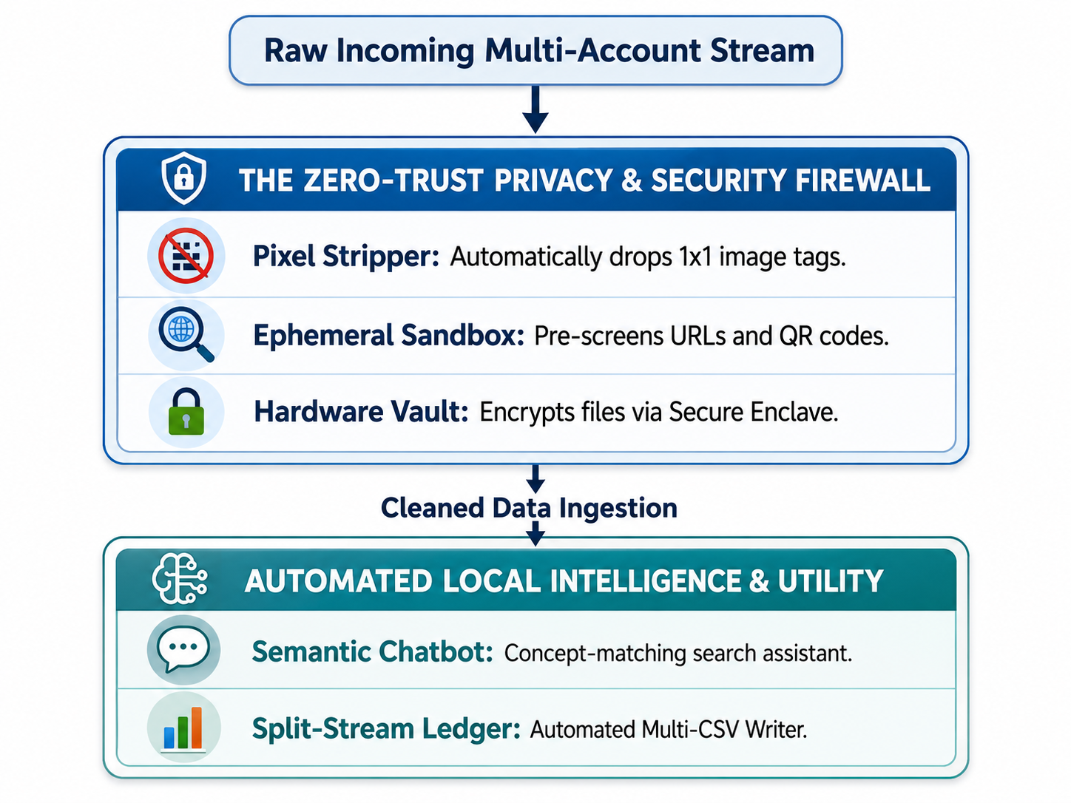-Stream Ledger: Automated Multi-CSV Writer. ──────────────────────────────────────────────────┘
- Aggressive Pixel Erasure: Rather than proxying images, the app's internal engine completely deletes all tracking pixel codes from the HTML script before rendering the screen, making you completely invisible to marketers.
- Real-Time Link & QR Proxying: When a user clicks a link or an embedded QR code image, the app intercepts the action. It opens an isolated, short-lived background container on your device to trace the final landing page for dangerous forms and phishing scripts before opening your system browser.
- Hardware Enclave Secure Vault: Sensitive materials like identity sheets and tax files are kept in a separate database partition encrypted using authenticated AES-256-GCM blocks. The decryption keys live exclusively inside the device's physical hardware storage chip (e.g., Apple Secure Enclave) and require FaceID/Fingerprint authentication to access.
- Contextual Semantic Chatbot Search: Kinetic Mail integrates a client-side conversational assistant powered by an embedded text-embedding vector index. If a user knows the content of an email or document but forgets the technical details, they can ask the chatbot in plain English: "Find that contract revision about the Q3 budget from last month" or "Look for the PDF invoice where I bought safety boots". The chatbot runs a local mathematical vector comparison and immediately pulls up the relevant mail object or attachment.
- Zero-Maintenance Accounting Ledgers: Programmatically parses transactional email formats locally. The engine automatically extracts payment network strings and account digits to execute thread-safe append commands to local files simultaneously: a global master expense sheet (ledger_master.csv) and dedicated card logs (ledger_[cardname]_[last4].csv).

4. THE IMPLEMENTATION & REVENUE PIPELINE

4.1 Solving the "Employee vs. Customer" Identity Overlap
When a user works at a business entity (receiving critical internal files) but also acts as a retail customer of that exact same brand (receiving spam coupons), typical domain filtering breaks down. Kinetic Mail implements a strict two-stage programmatic routing path to sort this without cloud intervention:
- Technical Signature Validation: The client matches incoming headers against an interior verified list. If the email originates from verified corporate IP footprints and distinct operational subdomains (e.g., @corp.levis.com), it moves directly to the Work Tab. Marketing service providers are cleanly shunted away.
- Local Light-LLM Context Check: If the company uses an identical domain for both streams, an optimized, local light-LLM processes the syntax of the text body. If the concept maps to internal company operations, it validates the Work Tab routing; if it contains sales terminology, it drops the item into Promotions.

4.2 The Telecom-Inspired Domain Registry Revenue Engine
To fund the platform cleanly without tracking users or selling personal datasets, the business operates a highly secure B2B framework:
- The Intent Directory: External corporate senders pay a recurring, volume-tiered subscription fee to register their official sending domain infrastructure and declare their intent (Transactional vs. Promotional) in our central database.
- The Brand Verification Badge: Every 24 hours, the local client application downloads a compressed, static cache map of this directory. When an email hits the local mailbox, its cryptographic signature headers (DKIM and SPF ranges) are verified against this local cache file. If it passes, the UI rewards the sender with a prominent Brand Verification Badge next to their name.
- The Win-Win Paradigm: For users, the badge guarantees an email is genuinely from their legitimate bank or retailer, not a copycat scammer. For businesses, the badge drastically optimizes email open rates and builds consumer trust. Because verification checks happen completely natively within the client app against the static cache, our servers never see the contents of our users' emails, allowing the infrastructure to scale seamlessly to millions of users at near-zero operating cost.

